User stories

# Story: register user

As a user I am able to create an account so that I can log into the application.

## Wireframe

## Acceptance criteria

* When a new user creates an account, the user and profile are registered
* When an email-address that’s already in use is entered, an error message is displayed

# Story: display items

As a user I can see a list of all my registered items.

## Wireframe

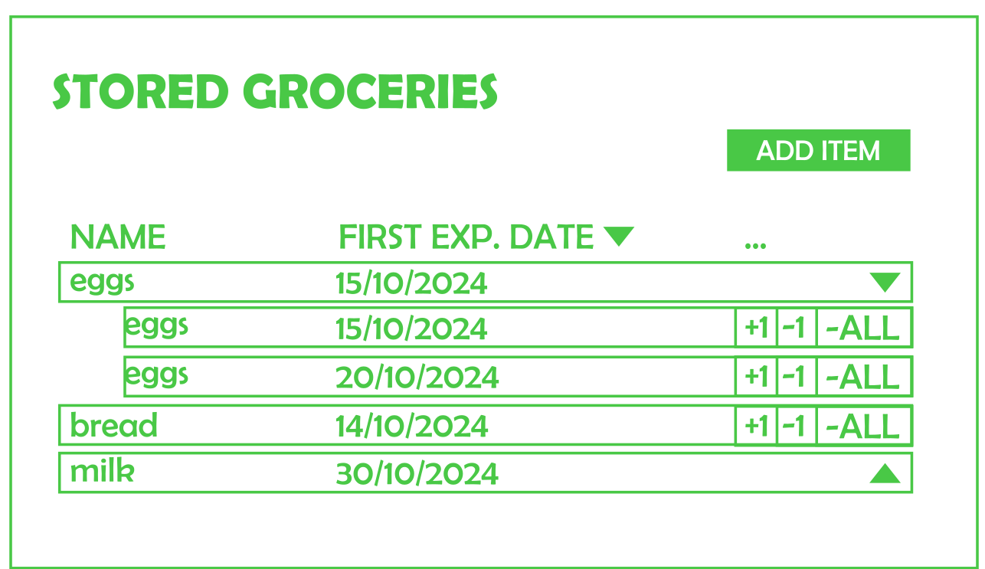  
The “…” means that these columns are not final yet, and more might still be added

The rows with an arrow are rows of grocery items that have been bought multiple times and have different expiration dates

## Acceptance criteria

* A page that fetches items from the back-end is added
* The page updates when an item is changed, added or removed

# Story: register item

As a user I am able to register an item with an amount and an expiration date.

## Wireframe

## Acceptance criteria

* The item list page has an “add” button that the user can use to add a new item
* When a user adds a new item, a new item is registered
* When an item with the same name and expiration date is entered, a suggestion to change the amount of an existing item instead is displayed

# Story: increase/decrease items

As a user I am able to decrease and increase the amount of a registered item.

## Wireframe

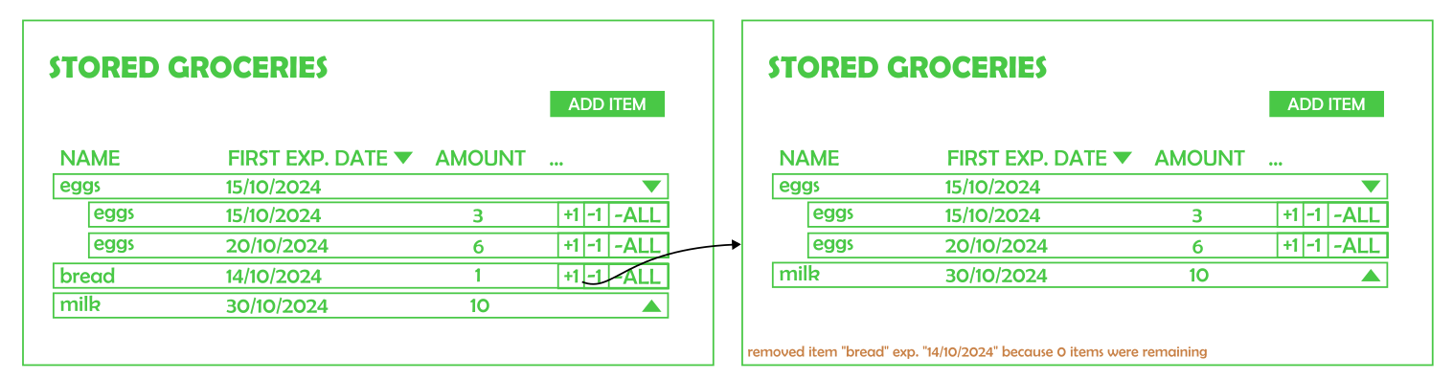

Popup at the bottom appears for like 10 seconds.

## Acceptance criteria

* On the item list page, the listed items get + and – buttons
* An increase or decrease in the amount of a registered item is registered
* When an item has an amount of 0, it is automatically removed

# Story: Family overview

As a user I am able to view my family/ families.

## Wireframe

I also added some extra buttons and stuff that we should also mention in the user story.

## Acceptance criteria

* A “family” page is added
* On the page a list for each family (and family ID) that the user belongs to is displayed. Every other family member is visible in the respective family’s list. Pending joining requests are displayed as well

# Story: Register family

As a user I am able to create a new family.

## Wireframe

## Acceptance criteria

* On the “family” page, a button to create a new family is added
* When a user adds a new family, the family is registered

# Story: Join family

As a user, I am able to search in the list of registered families and send a join request to the family.

## Wireframe

For wireframe of pending users in a family, see Story: Family Overview

## Acceptance criteria

* A search bar is added to the family page
* A user can click a button to request to join a family
* When the request button is clicked, other users in the family can see the pending request and can accept or deny the request

# Story:

## Wireframe

## Acceptance criteria

# Story:

## Wireframe

## Acceptance criteria

# Story:

## Wireframe

## Acceptance criteria

# Story:

## Wireframe

## Acceptance criteria

# Story:

## Wireframe

## Acceptance criteria